Even Semester (2019)



**BINUS UNIVERSITY**



**BINUS INTERNATIONAL**



**Assignment Cover Letter**

**(Individual Work)**

|  |  |  |  |  |  |  |  |
| --- | --- | --- | --- | --- | --- | --- | --- |
|  |  | | |  |  |  |  |
| **Student Information**: | **Surname** | | |  |  | **Given Names**  **Winson** | **Student ID Number**  **2201798345** |
| 1. | **Wardana** | |
|  |  |  |  |  |  |  |  |
| **Course Code** | **: COMP6510** |  |  |  |  | **Course Name** | **: Programming Language** |
| **Class** | **: L2BC** |  |  |  |  | **Name of Lecturer(s)** | : **Minaldi Loeis** |
|  |  |  |  |  |  |  |  |
| **Major** | **: CS** |  |  |  |  |  |  |
| **Title of Assignment**  (if any) | : **E-Book Library** |  |  |  |  |  |  |
| **Type of Assignment**    **Submission Pattern** | **: Final Project** | |  |  |  |  |  |
| **Due Date** | **: 01 - 07 - 2019** | |  |  |  | **Submission Date** | **: 01 – 07 -2019** |

The assignment should meet the below requirements.

1. Assignment (hard copy) is required to be submitted on clean paper, and (soft copy) as per lecturer’s instructions.
2. Soft copy assignment also requires the signed (hardcopy) submission of this form, which automatically validates the softcopy submission.
3. The above information is complete and legible.
4. Compiled pages are firmly stapled.
5. Assignment has been copied (soft copy and hard copy) for each student ahead of the submission.

# Plagiarism/Cheating

BiNus International seriously regards all forms of plagiarism, cheating and collusion as academic offenses which may result in severe penalties, including loss/drop of marks, course/class discontinuity and other possible penalties executed by the university. Please refer to the related course syllabus for further information.

# Declaration of Originality

By signing this assignment, I understand, accept and consent to BiNus International terms and policy on plagiarism. Herewith I declare that the work contained in this assignment is my own work and has not been submitted for the use of assessment in another course or class, except where this has been notified and accepted in advance.

Signature of Student: (Name of Student)

**Winson Wardana**

**Final Project Proposal**

**II. Table of Contents**

1. **Cover**
2. **Table of Content**
3. **Project Specifications**
4. **Solution Design**
5. **Code Implementation Discussion**
6. **Implementation**
7. **How it works**
8. **Evidence of Working Programme**
   * 1. **login**
     2. **signup**
     3. **homepage**
     4. **downloading books/adding**
     5. **Add books to the table and open**

**III. Project Specifications**

In this era, many people have trouble for reading books because there several issue for example: expensive books, hard to find the book you like, etc.

There are many people hard to find to read because you must make big effort to it. But in this time many people already common about technology such as handphone, laptop, etc and usually people use their gadget to search anything in the internet even you can find your favourite books, comics, magazine and anything you want to read.

So I came out with an idea to make a E-Book to store a book that you can download it in the internet. You can easily access the book without search it in the internet over and over again.

For this project, I use mySQL as my database, Java FX with sceneBuilder for my GUI, intelliJ for my IDE and a server.

**IV. Solution Design**

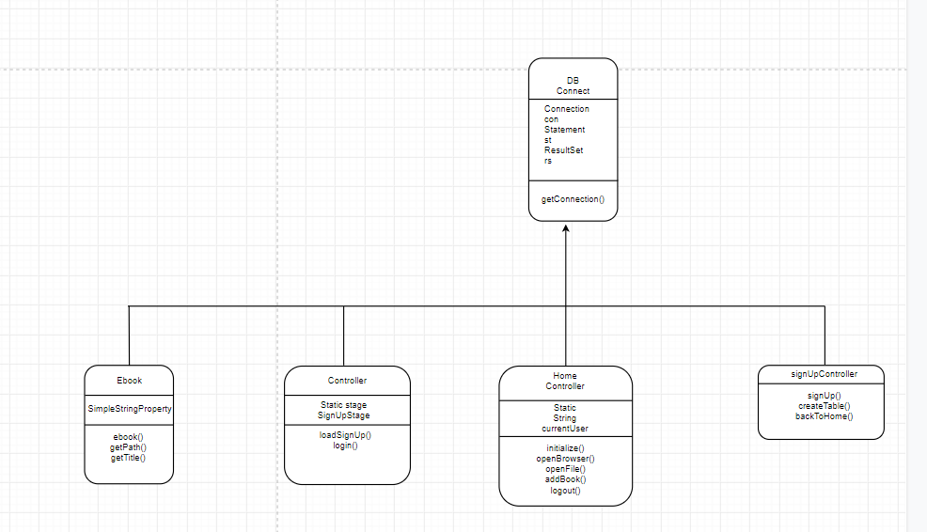

**V. Code Implementation Discussion**

**I. Implementation**

For this project, I use Java FX with sceneBuilder to build the user interface and I use mySQL for the database that stores all the users and the books using XAMPP to connect from the local host or server to mySQL and apache.

**II. How its works**

To make the explanation easier ill divide the code into different section

1. Login
2. Sing up
3. Login into Home Page
4. Downloading the books
5. Adding the book to the table
6. Open the E-book
7. Logout
8. Login

When the programme starts, the login menu will pop up, we can set the windows manually.

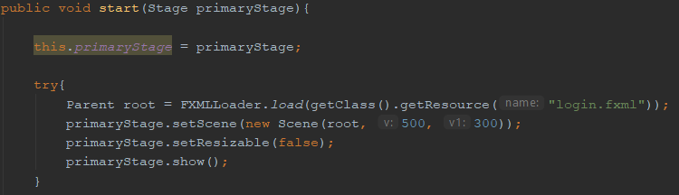

1. Sign up

At first you must register your name at the sign up menu every time you registered a name it will create a new table and it will store in the database

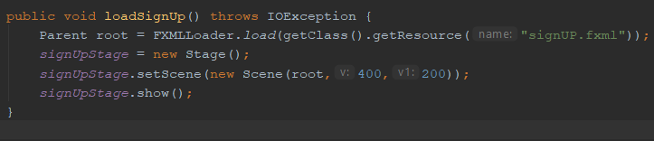

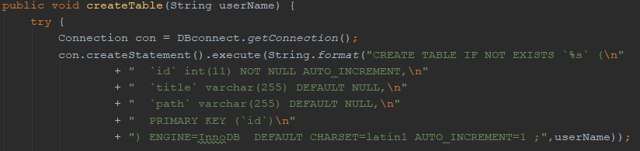

1. Login in to Home page

At the first the ill if there a username in the database if the name in the database that have been input in the sign up is equal to the name that I log to it will show you the user home page .

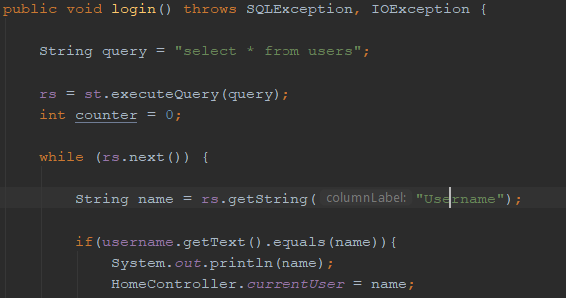



1. Downloading the books

In the user home page there is a download button, if you click the download button it will automatically open projectgutenberg for the web for you to download the book. Then you can search the book that you want.

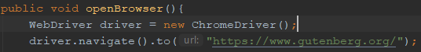

1. Adding the book to the table

After you successfully download the book. Click the add book button to open the file and show the folder that you put the download e-book at and then it will store the file to the table

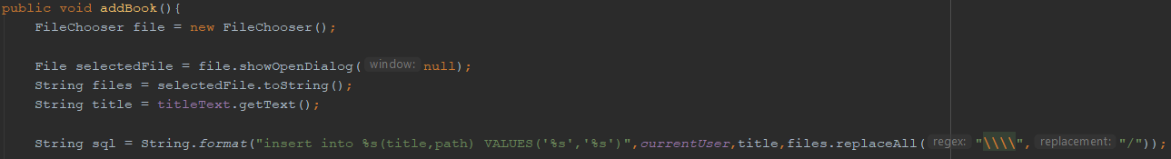

1. Open the E-book

The last step to click the file and the click the open button to open the e-book.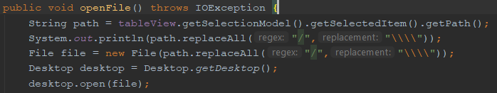

1. Logout

Then if you to logout it will go back into login menu for another user to use the e-book library.

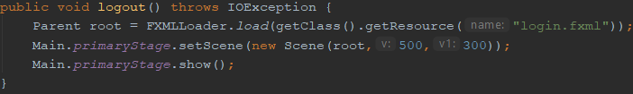

**VI. Evidence of Working Programme**

**i. Login**

This is the home page. When the user launches the application, this window will open. The home page will allow the user to see the login windows. 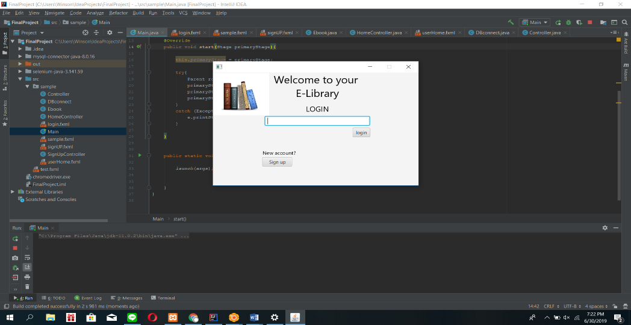

**ii. Signup**

You must first signup to continue or to login into the e-book library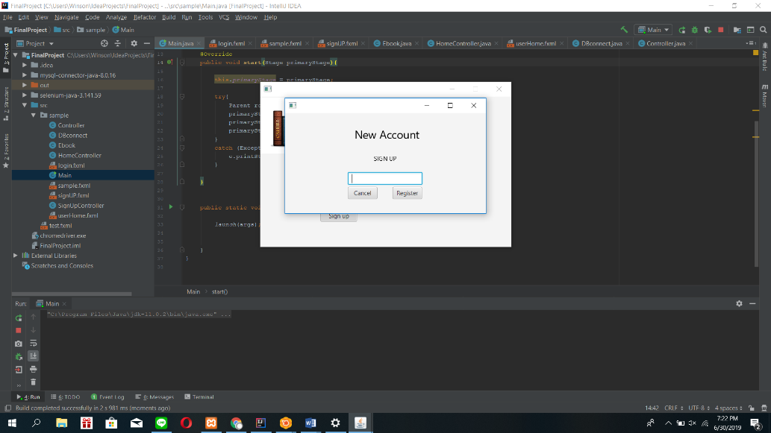

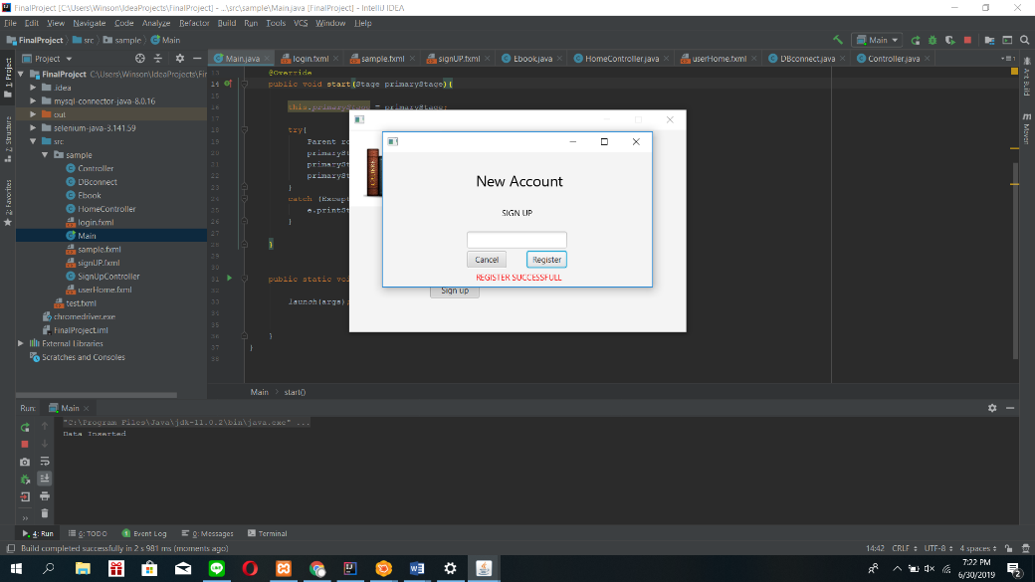

**iii. Home page**

Now the user is now log on into the account that have been registered

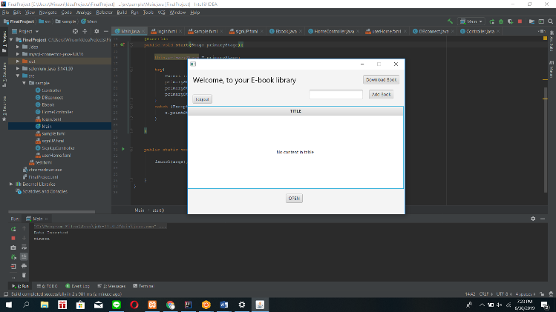

1. **Downloading/adding books**

It will show you the web that has been assigned by the programmer to download the book

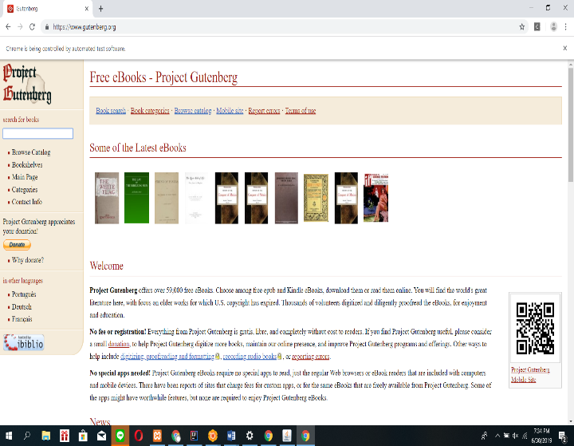

**v. Add book to the table and open**

The user can add the book to the table so it can be open and you must name it first

